HOME PAGE

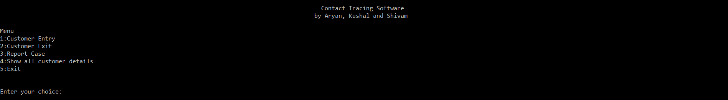

Data entry

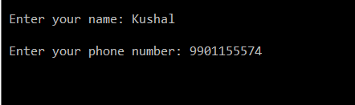

Showing the details of all customer

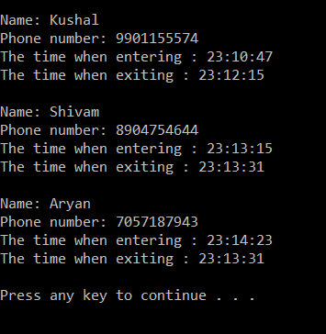

Test case 1

If the non-infected person exits after the infected person enters the store and before the infected person leaves.

Eg:- non-infected person enters at 3 and leaves at 5 while the infected person enters at 4 and leaves at 9

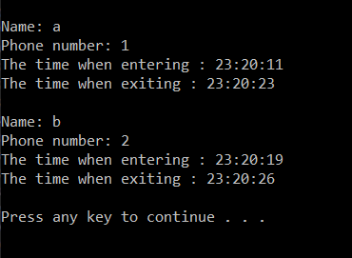

Running the scan for the infected person we get,

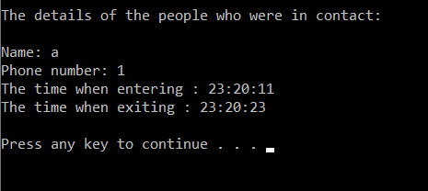

Test case 2

If the non-infected person enters after the infected person enters the store and leaves after the infected person leaves.

Eg:- non-infected person enters at 6 and leaves at 8 while the infected person enters at 4 and leaves at 7

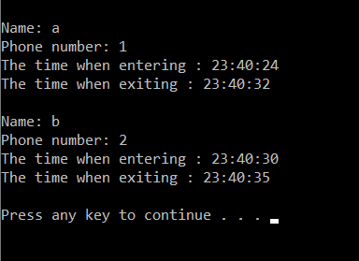

Running the scan for the infected person we get,

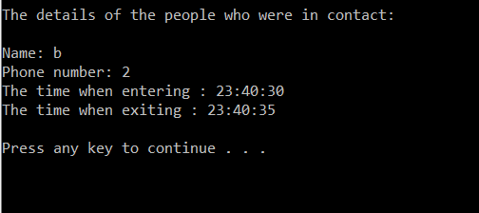

Test case 3

If the non-infected person enters the store before the infected person, and then leaves after the infected person leaves.

Eg:- non-infected person enters at 3 and leaves at 7 while the infected person enters at 4 and leaves at 6.

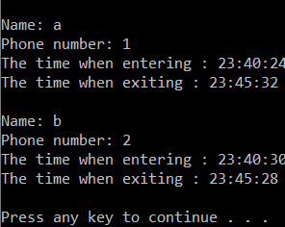

Running the scan for the infected person we get,

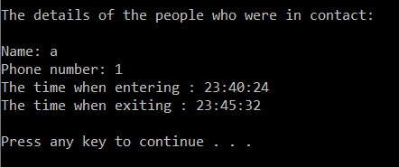

Test case 4

If the non-infected person enters the store after the infected person, and then leaves before the infected person leaves.

Eg:- infected person enters at 3 and leaves at 7 while the non-infected person enters at 4 and leaves at 6.

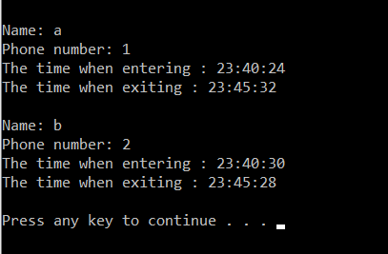

Running the scan for the infected person we get,

